Delete a country based on code
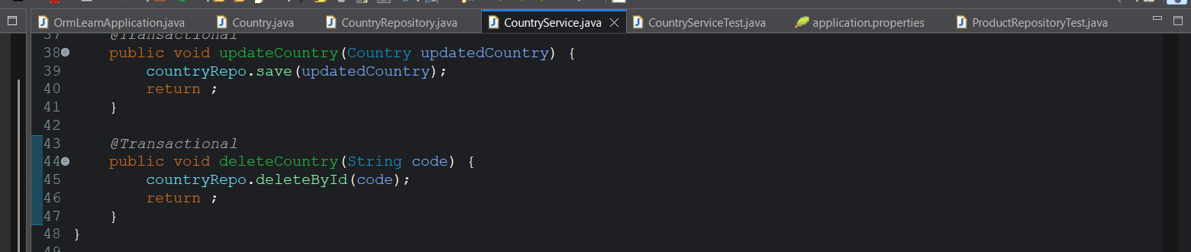
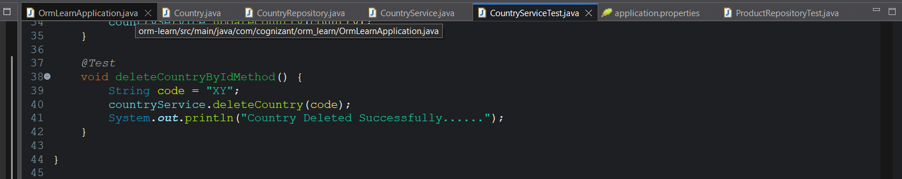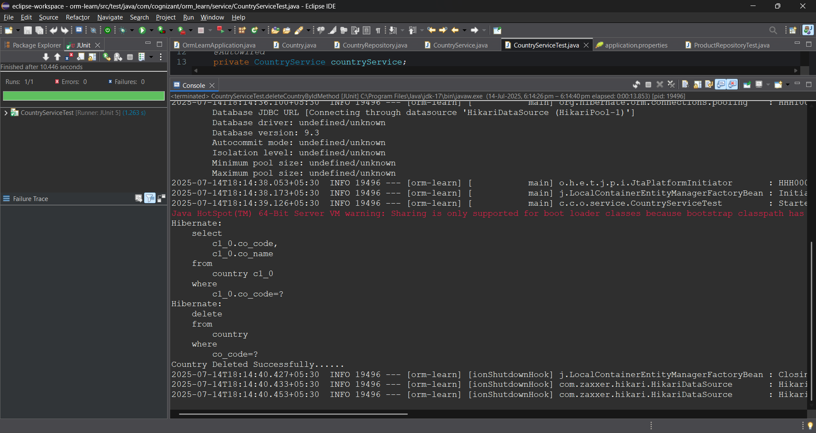

The country with code “XY” is deleted from the database.

